Install payment module

Payeer on CMS OpenCart 2.x

Using FTP client, copy the folders admin and catalog to your website root.

If you need to replacement file, you need to agree.

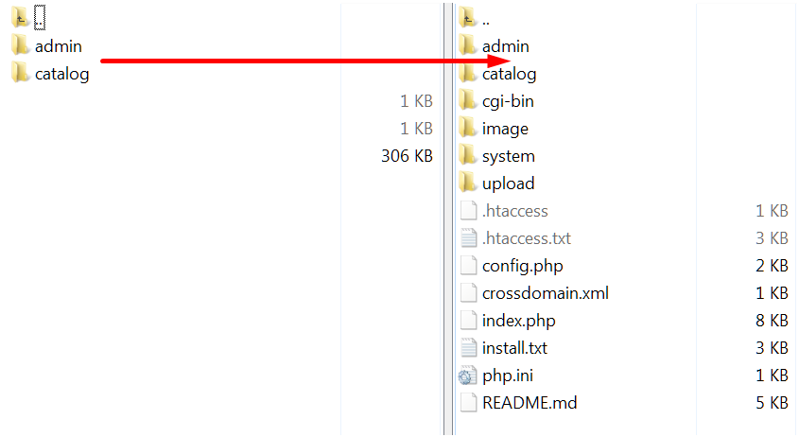

Go to the admin panel of your website. Go to the tab “Extensions -> Payments”. System Payeer should appear in the list of payment systems.

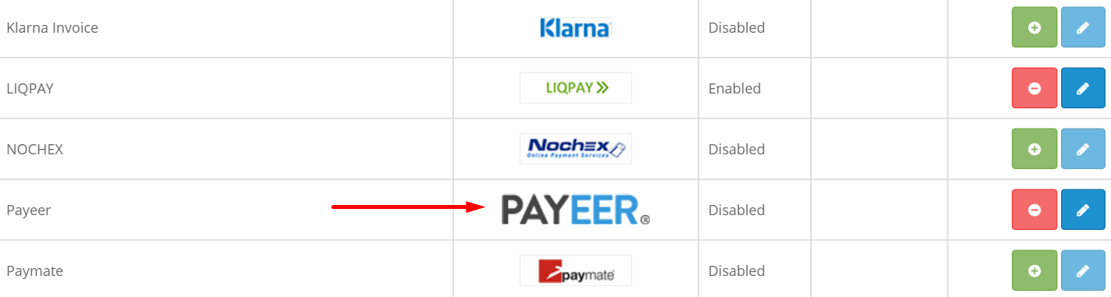

Opposite payment system Payeer click on the icon “Install”.

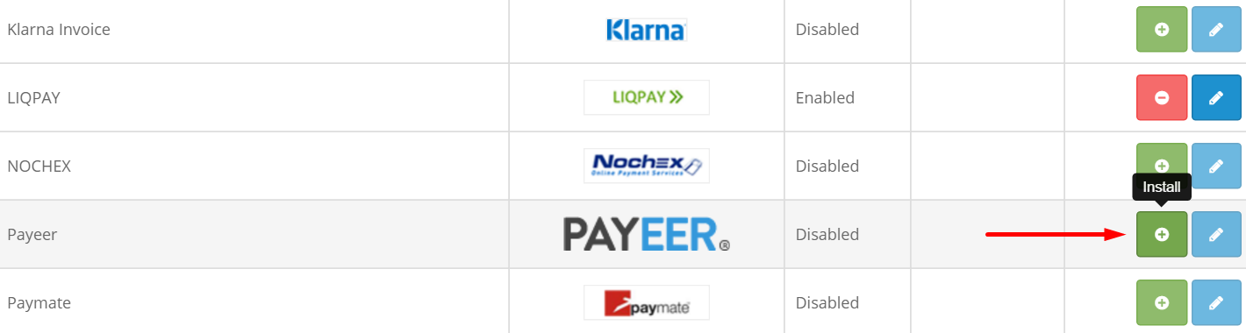

After installation, click on “Edit”.

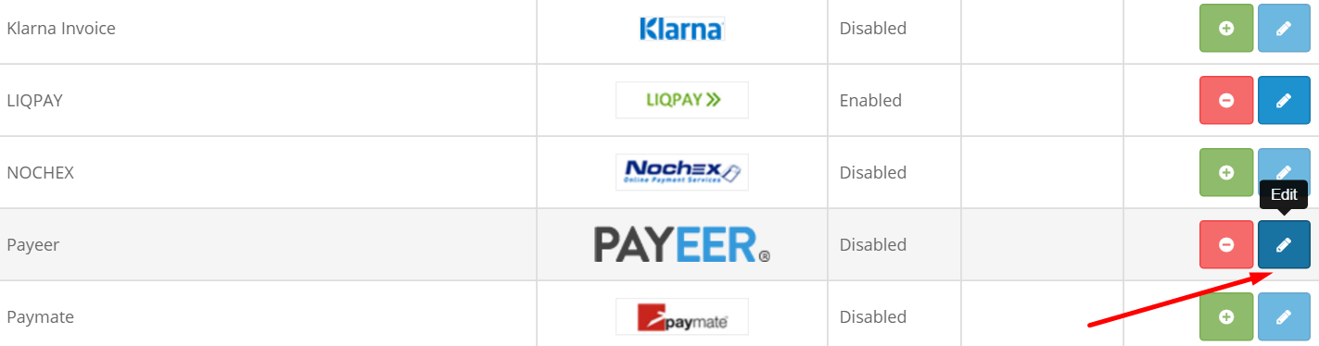

You entered the settings for the payment module Payeer.

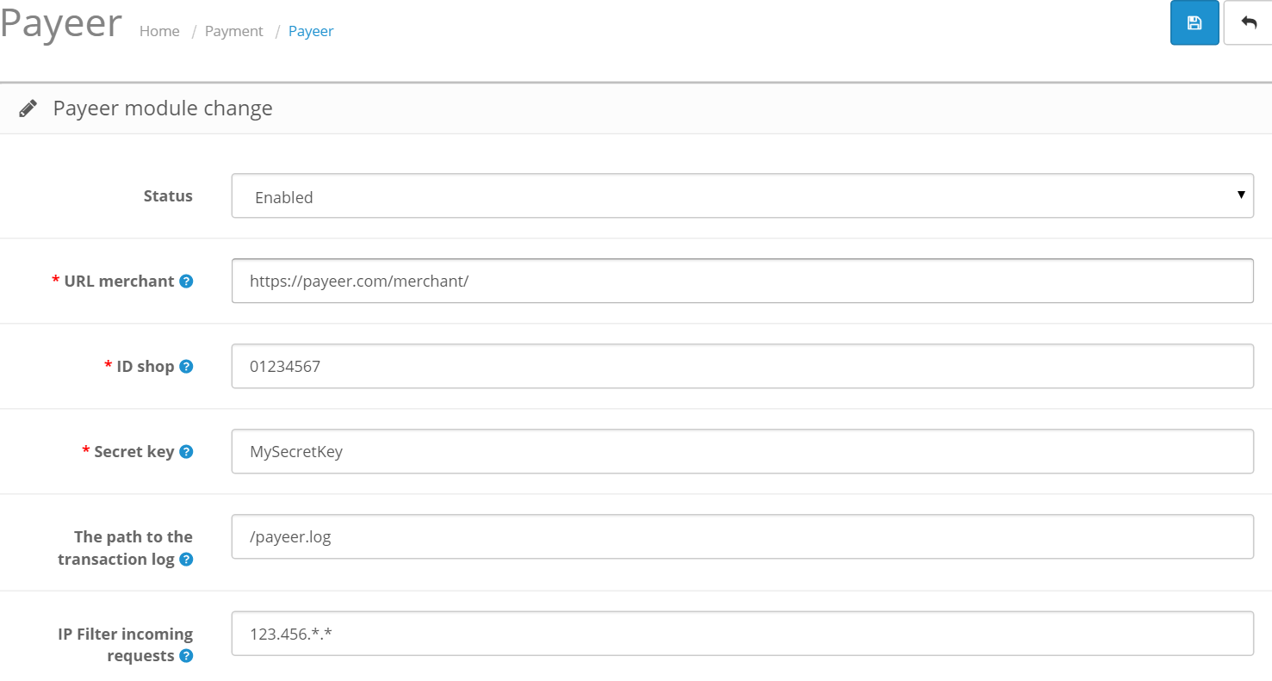

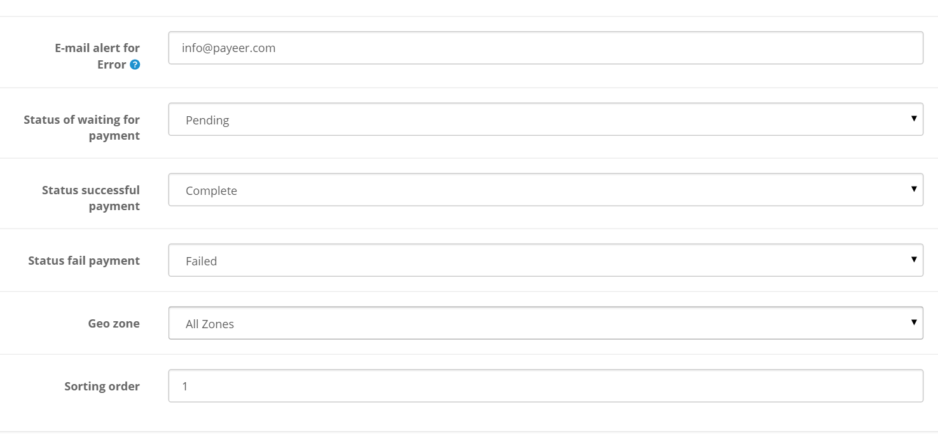

Fill in all required fields:

**Status**: enable;

**URL merchant**: link to payment system Payeer in (default <https://payeer.com/merchant/>);

**ID shop**: ID of your store in the system Payeer (can be found in the personal cabinet);

**Secret key**: the secret key of your store, you can also find in the personal cabinet;

**The path to the transaction log**: the path to the file intended to record the history of payment transactions in the payment system Payeer;

**IP filter incoming requests**: IP filter incoming requestsYou can specify the list of all trusted ip addresses of servers, separated by commas. You can also specify a mask instead of the ip address. If the field is empty, checking for trusted ip addresses is not performed.

For example:

192.168.71.87, 192.165.83.17, 192.178.34.15

Or 192.*.71.87, 192.165.83.*, 192.*.34.*

Or *.*.*.* - all available ip addresses;

**E-mail alert for Error**: email will be sent notifying you in case of an error of payment. The letter will state the reason and basic information about the payment;

Specify the status of orders payment

1. **Status of waiting for payment** (default, Pending);
2. **Status of successful payment** (default, Complete);
3. **Status of failure of payment** (default, Failed);

**Geo zone**: geographic area where affordable payment method;

**Sort order**: the order in the list of available payment methods.

Save the changes.

Then, enter the URL address in the “Dashboard > Merchant > Settings” on site payeer.com

Change the necessary fields

Status URL http:// *****/?route=payment/payeer/status/index.php

Success URL http:// *****/?route=payment/payeer/success/index.php

Fail URL http:// *****/?route=payment/payeer/fail/index.php

Where ***** is your domain.

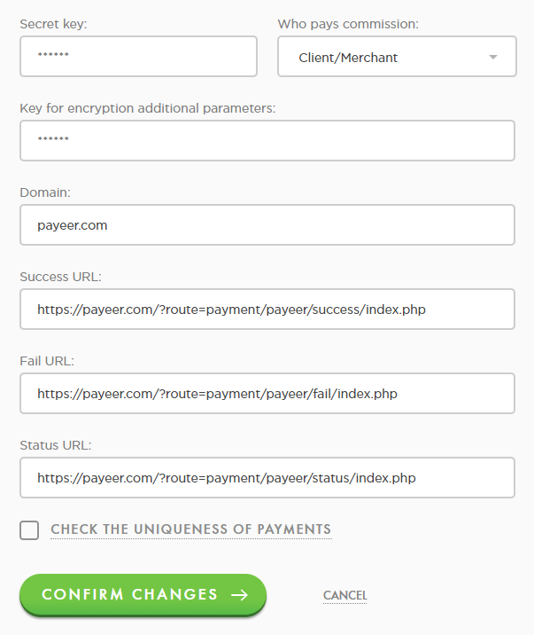

Confirm changes.  
Payeer module for CMS OpenCart 2.x is configured.